Forbes

You Want To Lead? Here’s The Scoop On What It Takes To Succeed

Rodger Dean Duncan Contributor
Rodger Dean Duncan covers leadership issues important to the workplace

Nov 13, 2024,10:08am EST



As with every year, an abundance of leadership books hit the market in 2024. One that deserves special attention is Leadership—The Inside Story: Time-Tested Prescriptions for Those Who Seek to Lead.

Author Willie Pietersen has the street cred to earn the attention of any interested reader. In addition to his teaching at Columbia University’s Graduate School of Business, he’s been a consultant to some of the world’s best-known organizations, ranging from Ericsson and John & Johnson to ExxonMobile and the Girl Scouts of America. This former Rhodes scholar has also served as chief executive of several multibillion-dollar businesses including Lever Foods and Seagram USA.

Pietersen writes that “Integrated leadership” is the intersection of three leadership domains. This begs the question: Why (and how) is that intersection important to a leader’s success?

“Essentially, leadership consists of three interdependent domains: Leadership of Self, Strategic Leadership and Interpersonal Leadership,” Pietersen says. “The key is to become an integrated leader by harnessing these three domains in the right combination. When one of these domains underperforms, it undermines the effectiveness of the other two. Understanding this helps us learn and grow as leaders.”

What specific mindsets, actions, and habits can leaders adopt to help them learn to learn?

Pietersen says we all learn intuitively, but few of us know consciously how we learn. “The driver is curiosity—not idle curiosity, but energetic curiosity in a pursuit of good answers,” he says. “Leadership is multidisciplinary, so I like to read widely beyond the confines of business books. My favorite topics are philosophy, evolutionary science and astrophysics. Each of these areas has helped form my own governing principles. For example, philosophy helps us find answers to three big questions: What’s true, what’s important, and what’s right. Evolutionary science reminds us of the need to continually adapt to the changing environment. And astrophysics teaches us humility and that although our lives are fleeting, we have just enough time to make a difference.”


Willie Pietersen

Even the smartest people among us can have their thinking skewed by bias. Pietersen identifies the forms of bias that can put a leader’s success at risk.

“We must grapple with major problems as we plot our future, but humans are not capable of total objectivity,” he says. “We are all subject to various biases that can distort our thinking. The only antidote to these ‘barriers to truth” is awareness—the ability to monitor our own thinking and that of our teams.”

He says the four most prominent biases he has observed are the Confirmation Bias, the Status Quo Bias, Denial, and Siloed Thinking. He regularly begins his strategy seminars with a collective review of these biases to create the awareness necessary to combat them.

Pietersen notes that skill with asking questions helps leaders make wise decisions.

“Darwinian logic tells us that the only way for organizations to achieve long term survival is to practice the art of continuous learning,” he says. “The key is the ability to ask the right questions. In fact, everything we know comes from a question someone asked. Socrates introduced us to this discipline. His mother was a midwife. He noted that she didn’t give birth to babies, but facilitated their delivery. He applied this metaphor to the art of asking good questions, saying, ‘I don’t give birth to ideas, but I facilitate their delivery.’”

In the same way, Pietersen says, “leaders must set the example by asking the kind of questions that invite the discovery of new ideas and thereby help their organizations adapt to change.”

Pietersen quotes Warren Buffett as saying, “The difference between successful people and really successful people is that really successful people say no to almost everything.” He explains how that applies to leaders.

“Focus wins and complexity paralyzes,” he says. “Carl von Clausewitz was a Prussian general who wrote On War, the definitive book on strategy in warfare. He gave us a definition of strategy that applies equally well in the business world: ‘The talent of the strategist is to identify the decisive point and then to concentrate everything on it, removing forces from secondary fronts and ignoring lesser objectives.’”

Note the words “removing” and “ignoring,” Pietersen says. “Success is all about harnessing concentration through subtraction. My mantra is: subtract first, then multiply.”
Taking a walk, Pietersen says, can be a pathway to breakthrough ideas. How does that work?
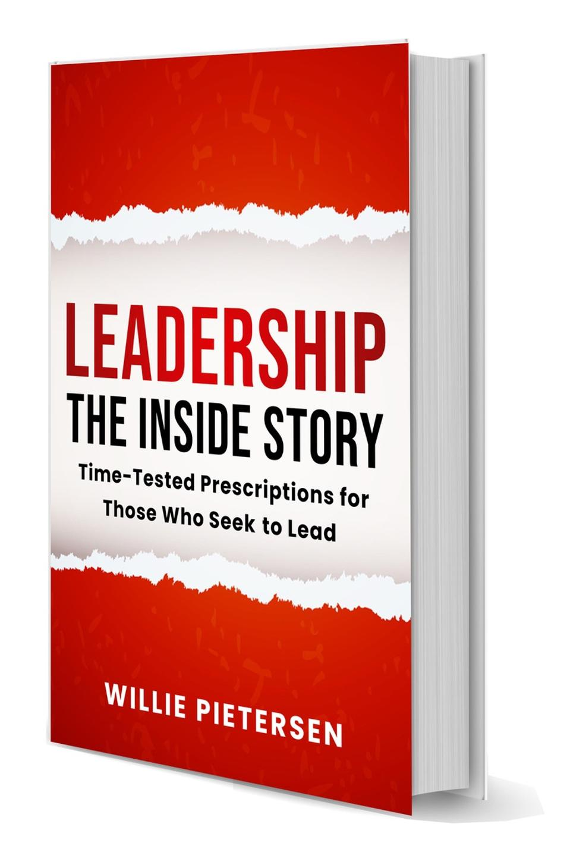
“I discovered the magic of walking by accident,” he says. “As a CEO for 20 years, I developed the habit of walking two miles at the start of every day. During these walks solutions to complex problems would often enter my head unbidden.”

He says there’s a scientific basis for this phenomenon. “Walking improves our cognitive function by releasing two chemicals: a protein called BDNF that energizes our neurons, and hormones called endorphins that produce a sense of calm and well-being. In today’s tumultuous environment, walking is surprisingly effective in helping us develop better thinking skills. A Stanford study released in 2014 found that walking increased a person’s creative output by an average of 60%.”

Pietersen explains how leaders can make it safe for their people to “manage up” and “speak truth to power” in ways that enhance the performance of all the players.

“As we grow in seniority, we become susceptible to what I call the curse of power,” he says. “People tend to tell you what they think will please you and are reluctant to bring you bad news. This presents a problem. The military knows that the most valuable intelligence is that which flows swiftly and accurately from the front lines to the command centers. The same is true for commercial organizations. When the communication conduit from the bottom up is blocked, organizations face a survival problem. It’s vital for organizations to develop a social contract that promotes this process of managing up as a crucial part of their learning system.”

Pietersen offers a wise reminder that “there is no such thing as a non-decision.” So why do so many leaders seem to have missed that truth, and what’s the cost to their effectiveness?

“Sometimes we’re tempted to delay or avoid making a tough decision. But delay has its price. The cost of doing nothing is not nothing. Inaction produces its own consequences and if we fail to act, events will make the decision without us. The vital discipline is this: When weighing a decision, always compare the intended outcome with what would happen if you don’t take that action. All decisions are comparative: the future consequences of a proposed action must always be measured against the future consequences of inaction.”

